**Take Home Program #1 – Due on or before Tuesday February 19, 2019 –**

**Objectives:** stream manipulator, input/output consoles, mathematic expression

|  |
| --- |
| **Important instructions:**   * *All programs must include comments at the top of your program: your name,* the class name (CSIT 575)*, program name and* ***the program description (purpose of the program).*** * *Copy and paste your* ***program code*** *and* ***output*** *in Part B of each program. Note: Use snipping tool to snip the output.* * *Once it is done, save and submit this word file via Canvas.* |

1. **HousingCost.cpp** program

Write a program that asks the use to enter their monthly costs for each of the following housing-related expenses:

* Rent or mortgage payment
* Utilities
* Phones
* Cable TV

The program should then display the total monthly cost and total of annual cost of these expenses.

**Sample run:**

Enter your monthly costs for the following:

Rent or mortgage: $1348

Utilities: $215

Phone(s): $99

Cable: $69

Total monthly housing costs: $ 1731.00

Total annual housing costs: $20772.00

**Part A: Pseudocode**

**Purpose of the program: //Adds together your individual costs to determine what you will pay each month and then multiplies by 12 to determine what you pay yearly**

**Input or given data: Rent, Mortgage, Utilities, Phone(s), Cable**

**Processing: Monthly cost = RentOrMortage + Utilities + Phone(s) + Cable**

**Yearly cost = (RentOrMortage + Utilities + Phone(s) + Cable) * 12**

**Output:**

**Part B: Copy and paste your program (source) code and the outputs after this line.**++++++++++++++++++++++++++++++++++++++++++++++++++++++++++++++++++++

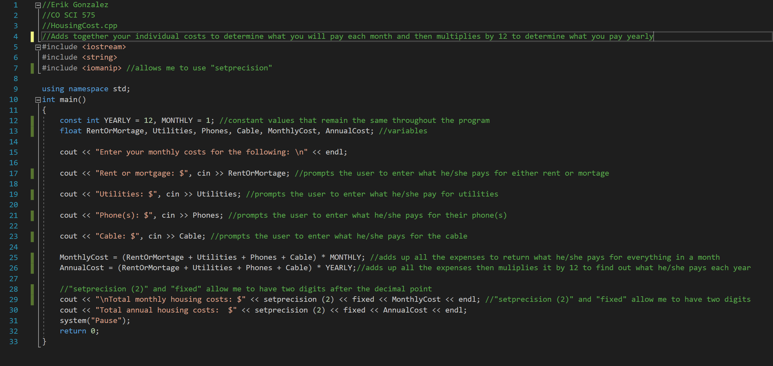

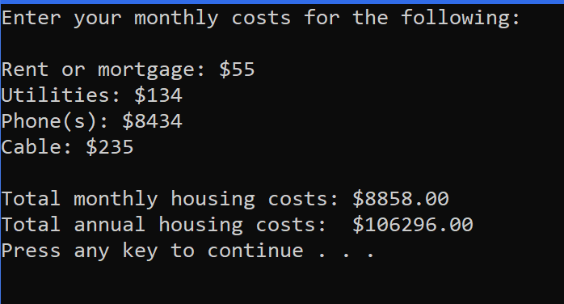

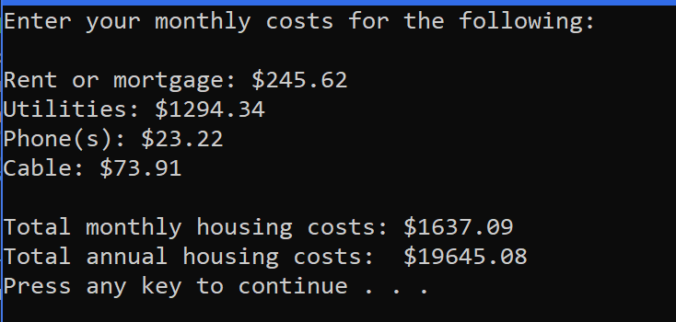

1. **RestaurantBill.cpp** program

Write a C++ program that computes the tax and tips on a restaurant bill. The program will ask the user the meal cost. The tax should be 9.75% (0.0975) of the meal cost. The program will calculate 15% (0.15) and 20% (0.20) tip rates before tax.

***Notes:***

* *Use name constants for tax rate, 15% tip rate and 20% tip rate*
* *You can make up your own data (meal cost) but the output format must be the same as sample runs.*
* *You must submit two outputs*

**Sample Run 1:**

Enter the meal cost: 56

******************************************

Meal Cost $ 56.00

Tax $ 5.46

Tip (15%) $ 8.40

Tip (20%) $ 11.20

Your total bill is 69.86 after 15% gratuity.

or

Your total bill is 72.66 after 20% gratuity.

**Sample Run 2:**

Enter the meal cost: 60.25

Meal Cost $ 60.25

Tax $ 5.87

Tip (15%) $ 9.04

Tip (20%) $ 12.05

Your total bill is 75.16 after 15% gratuity.

or

Your total bill is 78.17 after 20% gratuity.

**Part A: Pseudocode**

**Purpose of the program: The purpose of this program is to calculate the tax, a 15% tip, and a 20% tip based on the cost of a meal inputted by the user.**

**Input or given data: Tax 9.75%(0.0975), 15%(0.15), 20%(0.20)**

**Processing: Tax = CostOfMeal * 0.0975**

**15% = CostOfMeal * 0.15**

**20% = CostOfMeal * 0.20**

**15% = CostOfMeal + Tax + 15%**

**20% = CostOfMeal + Tax + 20%**

**Output: Your total bill is <blank> after 15% gratuity or <blank> after 20% gratuity**

**Part B: Copy and paste your program (source) code and the outputs after this line.**

++++++++++++++++++++++++++++++++++++++++++++++++++++++++++++++++++++

